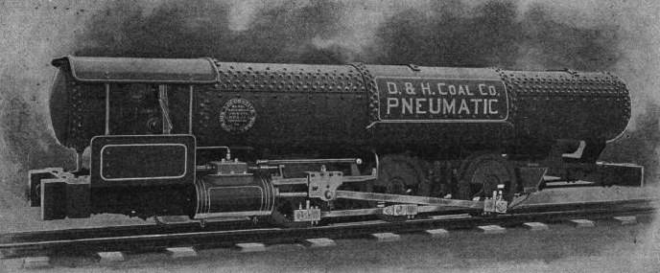

Above: This 0-6-0 locomotive is basically a large tank of compressed air on wheels. It was built for coal mining by the Dickson Locomotive works at Scranton, Pa, USA. The picture dates from 1899.
From web  In 1901 Dickson, joined with 7 other firms and formed American Locomotive Co. ((ALCO)  Storage Pressure | 600 psi
Working Pressure | 150 psi
Tank capacity | 170 cu ft
Weight | 16 tons

Compressed Air Locomotives on Display:
Porter 0-4-0, CN 3290, Built 1923 for Homestake Mining Company #5
Arizona Railway Museum, Chandler, Arizona
http://www.azrymuseum.org/roster/roster.html

Notes on Ohio Mining Journal Citations
Please use this identifier to cite or link to this item: http://hdl.handle.net/1811/32757

Image Below is From Google Books
Compressed Air Magazine Vol VII, No 8, Oct 1902 p2000-2006

Add appearing the Compressed Air Magazine Vol VII, No 1, March 1902

Notes from Compressed Air Magazine, July 1902, Vol VII, No 6 p1906-1908

From Engineering Index 1896-1900
